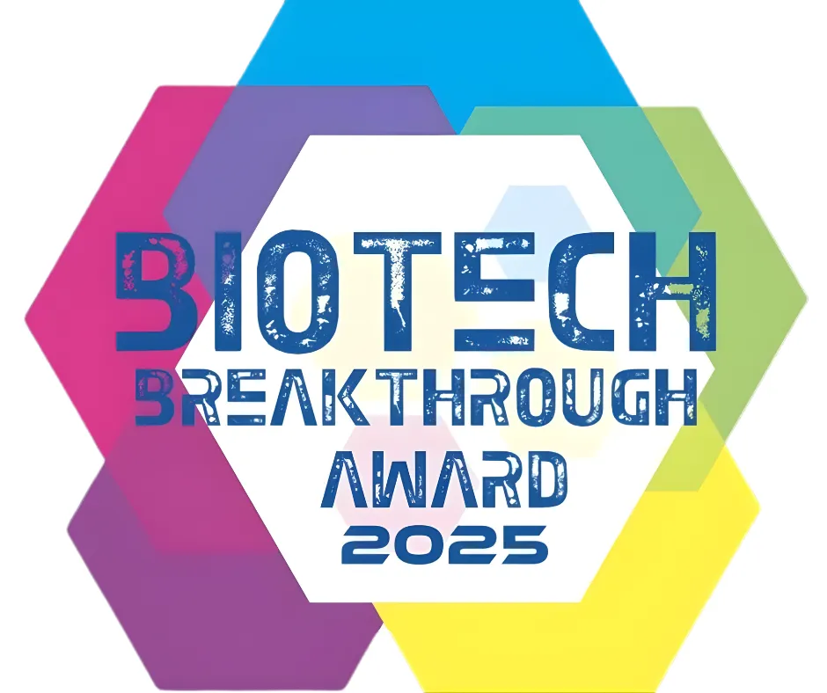

Annual Awards Program Recognizes Breakthrough Life Sciences & Biotechnology Innovation Around the World
LifeWave combines cutting-edge technology with nutrition, like Cellergize Morning which optimizes the effects of our own stem cells... We’re pleased to award them with ‘Stem Cell Innovation of the Year!’
LifeWave’s products offer a holistic solution... Together, X39 patches and Cellergize Morning harness your body’s natural energy...

The mission of the annual BioTech Breakthrough Awards program is to conduct the industry’s most comprehensive analysis...
We’re thrilled to accept the ‘Stem Cell Innovation of the Year’ award...
Lifewave Wins BIOTECH Breakthrough Award
LifeWave® Product Duo Wins “Stem Cell Innovation of the Year” in 2025 BioTech Breakthrough Awards Program

